Some significant November Days 2020
12 November, 1969
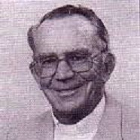
Father Eugene J. Cuskelly is elected Superior General of the MSCs (1969-1981).
He is the author of Jules Chevalier Man With a Mission, and today he is well appreciated for his response to Vatican II for all congregations to return to their roots and charism. He re-discovered the person of Jules Chevalier for the Chevalier Family and, with his council, introduced the now globally-used-expression "Spirituality of the Heart".
19 November, 2016
John Ribat MSC, Archbishop of Port Moresby, named a Cardinal. Cardinal Ribat is well known to our Sisters in PNG.
20 November, 1920
The first four MSC Sisters depart Germany for China! Years later, one of those four missionaries, Sr Solina lived in our communities in Melbourne and enjoyed sharing her Chinese recipes.

